# **Unix File System**

Unix file system is a logical method of **organizing and storing** large amounts of information in a way that makes it easy to manage. A file is a smallest unit in which the information is stored. Unix file system has several important features. All data in Unix is organized into files.

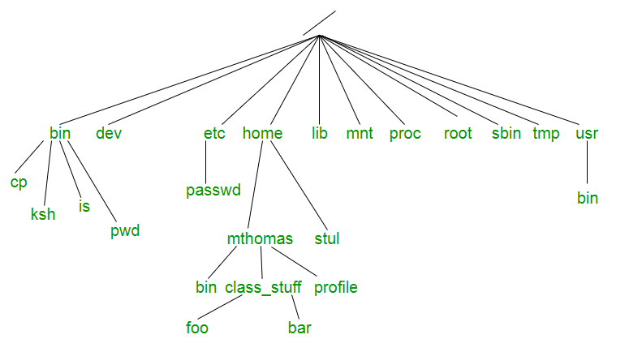

* **/ :** The slash / character alone denotes the root of the filesystem tree.
* **/bin :** Stands for “binaries” and contains certain fundamental utilities, such as ls or cp, which are generally needed by all users.
* **/boot :** Contains all the files that are required for successful booting process.
* **/dev :** Stands for “devices”. Contains file representations of peripheral devices and pseudo-devices.
* **/etc :** Contains system-wide configuration files and system databases. Originally also contained “dangerous maintenance utilities” such as init,but these have typically been moved to /sbin or elsewhere.
* **/home :** Contains the home directories for the users.
* **/lib :** Contains system libraries, and some critical files such as kernel modules or device drivers.
* **/media :** Default mount point for removable devices, such as USB sticks, media players, etc.
* **/mnt :** Stands for “mount”. Contains filesystem mount points. These are used, for example, if the system uses multiple hard disks or hard disk partitions. It is also often used for remote (network) filesystems, CD-ROM/DVD drives, and so on.
* **/proc :** procfs virtual filesystem showing information about processes as files.
* **/root :** The home directory for the superuser “root” – that is, the system administrator. This account’s home directory is usually on the initial filesystem, and hence not in /home (which may be a mount point for another filesystem) in case specific maintenance needs to be performed, during which other filesystems are not available. Such a case could occur, for example, if a hard disk drive suffers physical failures and cannot be properly mounted.
* **/tmp :** A place for temporary files. Many systems clear this directory upon startup; it might have tmpfs mounted atop it, in which case its contents do not survive a reboot, or it might be explicitly cleared by a startup script at boot time.
* **/usr :** Originally the directory holding user home directories,its use has changed. It now holds executables, libraries, and shared resources that are not system critical, like the X Window System, KDE, Perl, etc. However, on some Unix systems, some user accounts may still have a home directory that is a direct subdirectory of /usr, such as the default as in Minix. (on modern systems, these user accounts are often related to server or system use, and not directly used by a person).
* **/usr/bin :** This directory stores all binary programs distributed with the operating system not residing in /bin, /sbin or (rarely) /etc.
* **/usr/include :** Stores the development headers used throughout the system. Header files are mostly used by the **#include** directive in C/C++ programming language.
* **/usr/lib :** Stores the required libraries and data files for programs stored within /usr or elsewhere.
* **/var :** A short for “variable.” A place for files that may change often – especially in size, for example e-mail sent to users on the system, or process-ID lock files.
* **/var/log :** Contains system log files.
* **/var/mail :** The place where all the incoming mails are stored. Users (other than root) can access their own mail only. Often, this directory is a symbolic link to /var/spool/mail.
* **/var/spool :** Spool directory. Contains print jobs, mail spools and other queued tasks.
* **/var/tmp :** A place for temporary files which should be preserved between system reboots.

## Unix Architecture

Here is a basic block diagram of a Unix system −

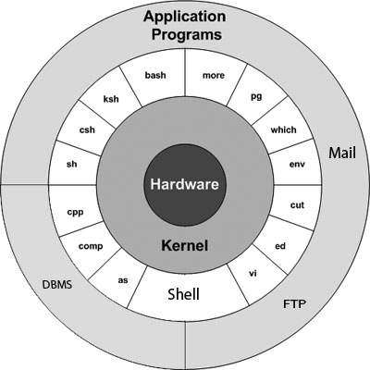

The main concept that unites all the versions of Unix is the following four basics −

* Kernel − The kernel is the heart of the operating system. It interacts with the hardware and most of the tasks like memory management, task scheduling and file management.
* Shell − The shell is the utility that processes your requests. When you type in a command at your terminal, the shell interprets the command and calls the program that you want. The shell uses standard syntax for all commands. C Shell, Bourne Shell and Korn Shell are the most famous shells which are available with most of the Unix variants.
* Commands and Utilities − There are various commands and utilities which you can make use of in your day to day activities. cp, mv, cat and grep, etc. are few examples of commands and utilities. There are over 250 standard commands plus numerous others provided through 3rd party software. All the commands come along with various options.
* Files and Directories − All the data of Unix is organized into files. All files are then organized into directories. These directories are further organized into a tree-like structure called the filesystem.

### System Shutdown

The most consistent way to shut down a Unix system properly via the command line is to use one of the following commands −

| **Sr.No.** | **Command & Description** |
| --- | --- |
| 1 | halt  Brings the system down immediately |
| 2 | init 0  Powers off the system using predefined scripts to synchronize and clean up the system prior to shutting down |
| 3 | init 6  Reboots the system by shutting it down completely and then restarting it |
| 4 | poweroff  Shuts down the system by powering off |
| 5 | reboot  Reboots the system |
| 6 | shutdown  Shuts down the system |